!!! figures are not matching!!!

Afera 5012 (GTF 6006, ISO 29863, EN 1943) Test Method

Static Shear Adhesion of Adhesive Tapes

1. Scope

1.1 These procedures help determine the ability of an adhesive tape to remain adhered under a constant load applied parallel to the surface of the tape and substrate.

1.1.1 Procedure A measures the shear adhesion when applied to a vertical standard steel panel.

1.1.2 Procedure B measures the shear adhesion when applied to a vertical panel covered with NIST SRM 1810A standard fibreboard.

1.1.3 Procedure C measures the shear adhesion when applied to a vertical panel covered with a fibreboard agreed upon by the buyer and seller.

1.1.4 Procedure D measures the shear adhesion of a reinforced filament tape when applied to a horizontal standard steel panel.

1.1.5 Procedure E measures the shear adhesion of a filament reinforced tape when applied to a horizontal panel covered with NIST SRM 1810A standard fibreboard.

1.1.6 Procedure F measures shear adhesion of a filament reinforced tapewhen applied to a horizontal panel covered with a fibreboard agreed upon by the buyer and seller.

1.1.7 Procedure G is the same as Test Method A except the test is conducted at an elevated temperature and a 10 minute dwell time.

1.2 These procedures provide a means of assessing the uniformity of the adhesive of a given type of adhesive tape (an example are tapes used for packaging applications). The assessment may be within a roll of tape, between rolls or production lots.

1.3 Variations in the tape backing and adhesive affect the results, therefore,these methods cannot be used to pinpoint the specific cause(s) of non-uniformity.

1.4 These test methods replaced ASTM D3654/D3654M EN 1943, Afera 4012, and PSTC-7

Afera: The European Adhesive Tape Association

GTF: Global Tape Forum

ASTM: American Society for Testing and Materials (USA)

EN: European Norm (Europe)

PSTC: Pressure Sensitive Tape Council (USA).

2. Reference Documents

2.1 ASTM Standards:

D3654/D3654M Standard Test Method for Holding Power of Adhesive Tapes

D 3715 Standard Practice for Quality Assurance of Pressure-Sensitive Tapes

D 5750 Standard Guide for Widths and Lengths of Pressure Sensitive Tapes

2.2 CEN Standards

2.2.1 EN 1943:2002 Adhesive Tapes – Measurement of Static Shear Adhesion.

2.2.2 EN 10088/2 Stainless Steels – Part 2: Technical delivery conditions for sheet/plate and strip for general purposes

2.3 PSTC Standards:

2.3.1 PSTC- 107 Shear Adhesion of Pressure Sensitive Tape.

3. Summary of Test Methods

3.1 Procedure A – Shear Adhesion to standard steel panel – a strip of tape is applied to a standard steel panel under controlled roll down. The panel is mounted vertically, a standard mass is attached to the free end of the tape and the time to failure is determined.

3.2 Procedure B – Shear adhesion to a standard (NIST) fibreboard – A strip of tape is applied to a panel covered with NIST SRM 1810A fibreboard under controlled pressure. The panel is mounted vertically, a standard mass is attached to the free end of the tape and the time to failure is determined.

3.3 Procedure C – Shear adhesion to a vertical fibreboard surface with controlled roll down. The fibreboard, corrugated board, or other substrate agreed upon prior to testing and described in the Report, Section 12. A standard mass is attached to the tape and the time to failure is determined. See Figure 1.

3.4 Procedure D – Shear adhesion to a standard steel panel. A strip of filament reinforced tape is applied with controlled roll down, to a standard steel panel with a 120° bend at one end. The panel is mounted horizontally, tape side up, with the free end of the tape allowed to hang vertically over the rounded end. A standard mass is attached to the end of the tape and allowed to act for specified time. See Figure 2.

3.5 Procedure E – Shear adhesion of filament reinforced tape to a standard (NIST) fibreboard - A strip of reinforced filament tape is applied under controlled roll down to a panel with a 120° bend, covered with NIST SRM 1810A standard fibreboard. The panel is mounted horizontally, tape side up, with the free end of the tape allowed to hang vertically over the rounded end of the panel. A standard mass is attached to the end of the tape and allowed to act for specified time.

3.6 Procedure F – Shear adhesion of filament reinforced tape to a fibreboard

–A strip of reinforced filament tape is applied under controlled roll down to a panel with a 120° bend at one end. The panel is covered with a fibreboard, corrugated board or other substrate agreed upon prior to testing and described in Section 12. The panel is mounted horizontally, tape side up, with the free end of the tape allowed to hang vertically over the round end of the panel. A standard mass is attached to the end of the tape and allowed to act for a specified time.

3.7 Procedure G

– This test method is conducted as described in Procedure A except the test is conducted at an elevated temperature.

3.8 For procedures A, B, C, and G the normal test area shall be (12 x 12) mm. A test area of (24 x 24) mm may be specified.(See Fig. 1).

3.9 For procedures D, E, F, the specimen width shall be 12 mm.

4. Significance and Use

4.1 Procedure A measures the ability of an adhesive tape to adhere to a standard steel panel under constant stress. This may or may not relate to the ability of the tape to adhere to other surfaces.

4.2 Procedure B may be used to determine the shear adhesion of tapes generally used to close fibreboard boxes in packaging applications.

4.3 Procedure C measures the ability of an adhesive tape to adhere to a non-standard fibreboard, liner-board or other substrate which is agreed upon for testing. This may be used to compare the shear adhesion of tapes to a particular surface or to compare the shear adhesion of a tape to a variety of surfaces.

4.3.1 The surface of similar fibreboard may exhibit considerable variations between paper mills, between batches from one mill, and within batches. Take care in the choice of samples and when comparing test results between substrates which may not be exactly the same.

4.3.2 The precision of test conducted on non-standard surfaces may vary as described in Section 13.

4.4 Procedures D, E, and F may be used to determine the ability of a filament reinforced tape to hold when placed under constant stress. The reinforced tapes may also be tested using Procedures A, B, and C.

4.5 Procedure G may be used to compare the shear adhesion of tape when applied to a standard steel surface and tested at an elevated temperature. See 10.6.3 and 12.1.8.

5. Apparatus

5.1 Specimen cutter - The specimen cutter shall hold two single edge razor blades in parallel planes, a precise distance apart, to form a cutter of exact specimens widths. Two cutters, 12 and 24 mm cutting width, shall be available or appropriate alternatives, which will not cause edge damage.

Note 1: The 12 mm cutter shall consist of a bar stock 12 mm wide. The edges for about 125 mm from one end shall be slightly rounded to form a handle. The width of the end of the bar shall be narrowed to exactly 12 mm minus the thickness of a single edge razor (one of two used as cutting edges). The razor blades shall be held in position using sideplates. The end of the cutter shall be cut away at a 45° angle to expose the cutting edge at one end of the blades. The edges shall be separated by (12 ± 0.10) mm. The 24 mm cutter shall follow the same description except the bar stock shall be 24.0 mm wide and shall be narrowed to exactly 24 mm minus the thickness of a single edge razor.

Note 2: These widths correspond to the primary metric (SI) units described in ASTM D 5750. If it is desirable to test slightly different widths (e.g. 12.5 or 25 mm) of specimens per 9.4, this should be noted per 12.1.5 .

Note 3: There may be several suppliers of these items.

5.2 Dispensing System, for solvents, such as a wash bottle.

5.3 Panel

5.3.1 For procedures A, B, C, and G H, a panel at least 50 mm long and 50 mm wide and not less than 1.1 mm thickness stainless steel 1.4301 in accordance with Specification EN 10088/2, 2R having a bright annealed finish. The surface roughness height shall be (50 ± 25) nm arithmetical average deviation from the mean line. One or both panel ends shall be ground to form a 90° angle with the surface. Panels showing stains, discoloration, or many scratches are not acceptable. New panels should be cleaned prior to use as 10.2.1, except with ten washes of the final solvent. Between uses, the panel test surface shall be protected from scratches and contamination, and the panels stored at conditions described in 8.1.

5.3.2 For Procedures D, E, and F, a panel as described in 5.3.1 shall have a 12 mm length of one end of the panel bent through an arc of 120° away from the test surface. The radius of the curvature of the finished surface at the bend shall be 1.5 to 3 mm. (See Fig. 2)

5.4 Roller, mechanically or hand operated.

5.4.1 A steel roller (85 ± 2.5) mm, in diameter and (45 ± 1.5) mm in width, covered with rubber approximately 6 mm in thickness, having a Shore scale A durometer hardness of (80 ±5). The surface shall be a true cylinder void of any convex or concave deviations. The mass of the roller shall be (2 ± 0.1) kg.

5.4.2 No part of the apparatus shall increase the pressure of the roller during use. The roller shall move either mechanically or by hand at the rate of (10 ± 0.5) mm/s.

5.5 Test Stands and Ancillary Apparatus.

5.5.1 Procedures A, B, C, and G – A test stand that shall hold the test panel, with the tape applied, at an angle of 0° – 2° with the vertical, so that when the mass is acting on the test specimen, no peel forces will be exerted on the tape.

5.5.2 Procedures D, E, and F

– A test stand that will support the test panel in a horizontal plane, approximately 300 mm above the work surface.

5.5.3 Clamp, that will allow the attachment of the mass to the specimen, distributing the load equally across the tape specimen width.

5.5.4 Test Masses:

5.5.4.1 Procedures A, B, C, and G. The test mass shall be (1000 ± 5) g or other mass as specified. The mass of the clamp described in 5.5.3 shall be included as part of the total mass.

5.5.4.2 Procedures D, E, and F. The test mass shall be (4.5 ± 0.2) kg or other mass as specified. The mass of the clamp described in 5.5.3 shall be included as part of the total mass.

5.5.5 Timing System

5.5.5.1 For Procedures A, B, C, and G, to measure the interval between the application of the load to the specimen and its separation from the panel.

5.5.5.2. For Procedures D, E, and F, a suitable means of measuring the amount of slippage of the tape to 1 mm on the panel after the mass has acted for 48 hours.

6. Reagent Materials

6.1 Purity of Reagents – Reagent grade chemicals should be used in all tests. Other grades may be used, provided it is first ascertained the reagent is of sufficiently high purity to permit its use without lessening the accuracy of the determination.

6.2 Solvents:

6.2.1 Any of the following solvents may be used for cleaning;

6.2.1.1 Diacetone alcohol non-residual, technical grade or better.

6.2.1.2 Methanol (95 %).

6.2.1.3 Methyl Ethyl Ketone (MEK).

6.2.1.4 n-Heptane.

6.2.1.5 Acetone.

6.2.2 For final cleaning, before each test, MEK or Acetone shall be used.

6.3 Cleaning Material, absorbent; surgical gauze, cotton wool or tissue. To be suitable, materials must be lint-free during use, absorbent, contain no additives that are soluble in the solvents listed in 6. and made exclusively from virgin materials.

7. Sampling

7.1 Sampling shall be in accordance with ASTM Practice D 3715/D 3715M or other formal sampling procedure agreed to by both parties for referee testing. For Procedures A, D, and G three replicate specimens shall be averaged in accordance with Section 11 for each test result. For Procedures B, C, E, and F five replicate specimens shall be averaged. No single value shall be considered as representative of the roll under test.

8. Conditioning

8.1 Condition the sample rolls of tape in the standard conditions of (23 ± 1) °C and (50 ± 5) % relative humidity. Test at these conditions unless otherwise specified (see 12.1.7). If these tolerances cannot be maintained, the closest possible tolerances shall be used and these revised tolerances quoted in the report. See 12.1.7.

Note 4: Caution – The tester should know that by prolonged handling of the test panel, heat from the hand is transmitted to the test panel. Therefore, just prior to, during and after application of the specimen to the test panel, the panel should be handled as little as possible.

9. Test Specimens

9.1 Removal from Roll:

9.1.1 Unwind and discard at least three but no more than six outer wraps of tape from the sample roll before taking specimens for testing.

9.1.2 Remove three specimens per sample roll for each test to be performed for Procedures A, D, and G; and five specimens per roll for Procedures B, C, E, and F. Remove specimens from a freely rotating roll at the rate of 500 to 750 mm/s. Where width or other factor causing a high adherence to backing makes it impossible to remove the specimen at the prescribed rate, remove it at a rate as close to 500 mm/s as possible.

9.2 When tape is wider than specified in the test method, cut the specimen from the centre of the strip removed from the roll in accordance with 9.1.2.

9.3 Apply specimen within 5 min after unwinding.

9.4 Test specimen size.

9.4.1 Procedures A, B, C, and G.The test contact area shall be (12 ± 0.5) by (12 ± 0.5) mm, or other width, as specified. (24 ± 0.5) mm by (24 ± 0.5) mm may be used. The length of the specimen shall be approximately 150 mm.

9.4.2 Procedures D, E, and F specimens shall be (12 ± 0.5) mm in width and approximately 300 mm long.

10. Procedures

10.1 For Procedures B, and C, apply by means of a double-coated adhesive tape a 30 by 75 mm piece of fibreboard (see 3.2, 3.3) with the 30 mm dimension centred on the 50 mm dimension at one end of the test panel (see 5.3.1 and 5.3.2).

Note 5: Take care that the fibreboard is applied with the proper side up and is oriented so that the grain of the paper, machine direction (MD), is perpendicular to the intended direction of the shear stress (See Fig. 1).

10.2 Procedure A

10.2.1 Dispense one of the solvents listed in 6.2.1 onto the panel, wiping to dryness with fresh absorbent cleaning material. Repeat for a total of three washes with this solvent. Final wipe shall be MEK or Acetone. The panels should be allowed to dry for at least 10 minutes. Panels not used within 10 hours should be recleaned.

Note 6 – Discard panels showing stains, discoloration, or many scratches. Avoid contacting panel surface with fingers. During storage, panels should be protected from damage or contamination.

10.2.2 Centre the test specimen on the 50 mm dimension at one end of the test panel and apply without added pressure to cover an area exactly (12 x 12) mm, unless other width specified, with the tape. Mask the exposed adhesive of the free area of the specimen.

10.2.3 To prevent cutting the specimen by the end of the panel during roll down, place another panel of the same or slightly lesser thickness under the free masked end of the specimen, and in contact with the end of the panel prior to roll down. Roll down the applied test area twice, once in each lengthwise direction.

10.2.4 Individually prepare each specimen and test within 1 minute. For tapes other than packaging tapes, other dwell times may be used but must be reported. See 12.1.4.

10.2.5 Place the clamp on the masked free end of the specimen, ensuring that the clamp extends completely across the width of the specimen and is aligned to uniformly distribute the load.

10.2.6 Place the test assembly in the test stand so that the free end of the test specimen is vertical, ensuring that no peel forces act on the specimen.

10.2.7 Apply the 1000 g mass to the clamp gently so as to cause no impact force on the tape specimen. Record the time elapsed until the tape specimen has completely separated from the test panel.

10.3 Procedures B and C

10.3.1 Conduct these tests as described in 10.2 except the test panel shall be covered with fibreboard described in 10.1.

10.4 Procedure D

10.4.1 Clean, as described in 10.2.1, a test panel described in 5.3.1.

10.4.2 Apply one end of the specimen, about 100 mm in length, adhesive side down, to the longitudinal surface of the test panel. The tape must be at a true right angle to the bent edge of the panel. Allow the remaining length to extend over and beyond the bend edge of the panel.

10.4.3 Using a square, cut across and through the width of the tape specimen 75 mm back from the front of the bend in the horizontal plane of the test panel surface.

10.4.4 Roll twice, once in each lengthwise direction.

10.4.5 Place the clamp on the free end of the specimen, ensuring that the clamp extends completely across the width, and is aligned so as to distribute the load uniformly.

10.4.6 Place the test assembly in the test stand so that the panel is horizontal, tape side up, and the free end of the test specimen is vertical. Apply the 4.5 kg mass to the clamp gently so as not to cause any shear impact force on the specimen.

10.4.7 At the end of 48 h under load, examine the specimen for evidence of slippage. Measure any slippage that has occurred to the nearest 1 mm.

10.5 Procedures E and F.

10.5.1 Conduct these tests as described in 10.4 except the test panels shall be covered with fibreboard as described in 10.1.

10.6 Procedure G.

10.6.1 Prepare test specimens as described in 10.2.1, 10.2.2, 10.2.3, 10.2.4 and 10.2.5.

10.6.2 Place the test stand, with specimen in place, in an oven maintained at (50 ± 1) °C, or other temperature, as specified.

10.6.3 Allow to condition for 10 min., then apply the 1000 g mass to the clamp gently so as not to cause any shear impact force on the tape specimen. Record the time lapsed in which the tape specimen has completely separated from the test panel. (See 12.1.8).

11. Calculations

11.1 Procedures A, B, C, and G – To determine the test result for each roll of tape, convert each of the specimen test results (times to failure) to its common or natural logarithm. Obtain the arithmetic mean of all logarithms and then convert back to time by obtaining the appropriate antilogarithm. This gives the test result for the roll of tape under consideration in the sampling plan.

11.2 Procedures D, E, and F – The average slippage in mm shall be reported.

12. Report

12.1 The report shall include the following:

12.1.1 Statement including which test method was used and indicating any deviation from the method as written.

12.1.2 Identify the source of each roll of tape

12.1.3 For procedures A, B, C, and G, the time for the tape to separate completely from the panel. For procedures D, E, and F, the amount of slippage in mm to the nearest mm.

12.1.4 Dwell time, if other than the standard 1 minute.

12.1.5 Test specimen size for procedures A, B, C, and G if other than 12 by 12 mm. Width of specimen for procedures E, F, and G if other than 12 mm.

12.1.6 Conditioning if other (23 ± 1) °C or (50 ± 5) % relative humidity.

12.1.7 Test temperatures for procedures A, B, C, D, E. and F, if other than 23 °C and test temperature for procedure G, if other than 50 °C.

12.1.8 Mode of Failure – Cohesion (cohesive strength, internal bond) – The

ability of the adhesive to resist splitting. Good cohesion is necessary for clean removal. Adhesion – a bond produced between a tape adhesive and a surface for procedures A, B, C, and G.

12.1.9 Fibreboard substrate if procedure C, or F is used.

13. Precision and Bias Statement

13.1 The surfaces of similar fibreboard may exhibit considerable variations between paper mills, between batches from one mill, and within batches, therefore results using different fibreboard should not be compared except when one wishes to use Procedure C as a means of comparing how well a given tape will adhere to different fibreboard.

14. Keywords

14.1 Adhesive tape; filament tape, shear adhesion.

Issued September 1979

Revised October 2003

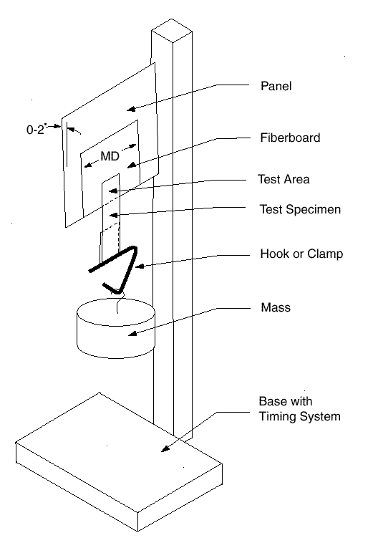

Figure 1.

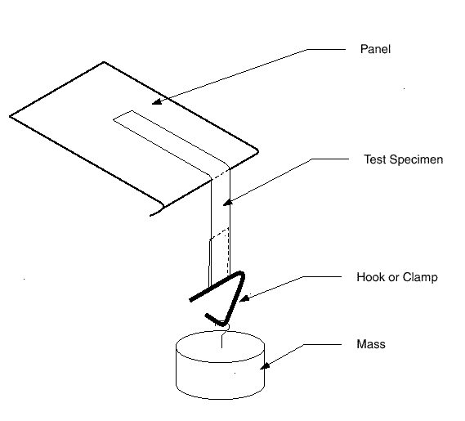

Figure 2.

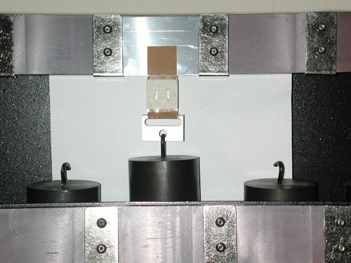Figure 3. Shear test

## 

Figure 4. Shear test

## 